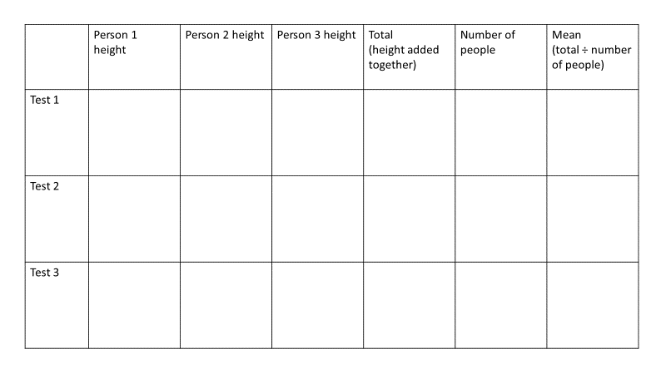

Ordered data:
Test 1:
Test 2:
Test 3:
Ordered data:
Test 1:
Test 2:
Test 3:

